On the road again: driving after a brain injury
Picture courtesy of the North Wales Driving and Mobility Assessment Centre

Introduction
Even if it’s just popping down to B&Q, we consider driving something of a human right. That feeling doesn’t disappear just because we’ve had a brain injury. In fact, we can become even more eager because it’s a sign that we’re recovering, that normality is restored, and it helps bring back the independence that a long hospital stay and physical disabilities may have stolen. Not to mention it helps us get to appointments!
The problem is that a lot of the skills we need for driving are the very ones that a brain injury is likely to have affected. For example, you might have problems judging distance and speed – your own, and other road users. The high levels of concentration required for driving may also tire you quickly, and therefore impact some of the cognitive requirements for what is actually quite a complicated task eg
- Attention
- Risk management
- Decision making
- Visual perception
- Reaction times
- Memory

Crucially, brain injury also sometimes affects our ‘insight’ – in other words, we’re not always aware of how we’ve changed. That’s not to say driving after a brain injury is impossible, but safety – ours, and that of other road users – must come first. And that’s why we need to involve other people, including the people responsible for our care, who understand the effects of our injury, and the experts at the DVLA, in deciding whether we’re fit to drive.

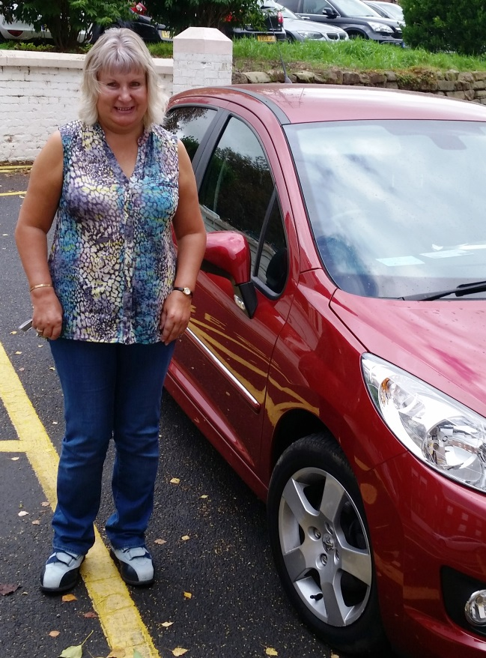

What are the rules?
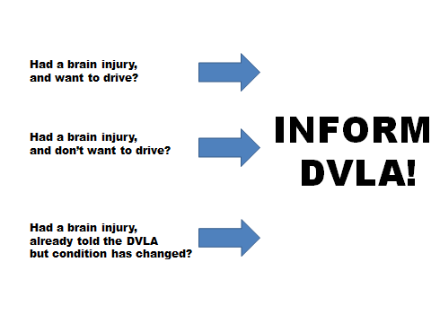
THE DVLA MUST BE INFORMED OF ANY MEDICAL CONDITION WHICH MAY AFFECT DRIVING.

It is YOUR responsibility to do this. And it is an offence NOT to inform them. In fact, you can be fined £1000!
Brain injuries are one of the many conditions that the DVLA needs to consider in relation to fitness to drive.
One issue is that brain injury can increase the risk of having an epileptic fit, or seizure. Many drivers with a brain injury are considered to be safe, and you CAN be epileptic and drive, but only if it is controlled by medication and you have not had a fit for over 12 months (and are only applying for Group 1 ie car/motorbike).
Even if you aren’t driving and don’t intend to in the future THE DVLA SHOULD STILL BE INFORMED and you need to surrender your licence to them. If you’ve previously informed them, but your ability to drive or your condition has changed, they also need to be informed.
You should also inform your GP and, if you are receiving aftercare, whichever type of brain injury specialist you are seeing eg Neuropsychologist/Occupational Therapist.

For further information see the DVLA’s own guidance at www.direct.gov.uk/motoring/driverlicensing/medicalrulesfordrivers
If you are in the care of the Acquired Brain Injury team for Cheshire/Wirral or a HIP member, we can help you with this, and all the form filling!

What happens next?
Once you notify the DVLA of your injury, there are three main stages in their decision-making.

Stage One
They will write to you asking permission to request relevant information from medical professionals. You need to reply to this within 3 weeks, otherwise they may revoke your licence for non-compliance.

Stage Two
If you give consent within the time period and make a self declaration in the questionnaire, they will contact the professionals involved in your care to get more information about your current condition. If this report doesn’t contain enough information for them to make a decision, you may need to undergo assessment.

Stage Three
The DVLA may ask for more tests, which could be to look at your visual ability and/or a driving assessment. If a driving test is required, this may mean going to a specialist centre where you will be seen by a range of experts to assess your fitness to drive. You will then drive under the supervision of an examiner, usually in a dual control car. You will be given a verbal report and the written report will be sent to the DVLA for their decision. In some cases, if there is not a suitable special centre near to you, you may be asked to do the standard test.
For Cheshire residents, we have a good working relationship with the North Wales Driving and Mobility Assessment Centre - http://www.wmdas.co.uk/ - and can let you know about the people you’ll see there and what will happen.
The DVLA may also ask you to visit a local doctor (usually a GP) who has been appointed by them to assess medical fitness to drive.

If this all seems cumbersome and frustrating and stressful…the process is there for a reason, remember. It’s about keeping you, and others, safe. So that when you’re passed by the DVLA, you can take to the roads with confidence again – you’re OK!

Decision Time

Once you’ve gone through the process above, you’ll be notified of the DVLA’s decision, which may be one of the following:

- You can keep your licence, or receive a new one
- You can be issued with a fixed period (1/2/3 years) review licence, which would mean that a future assessment would be needed when it expires
- A licence may be issued which requires your vehicle to be adapted to help with any physical disabilities caused by the injury
- Because they are unsure of your fitness to drive, you’re issued with a Provisional Disability Assessment Licence, which gives you up to 3 months of driving lessons before you are retested
- The DVLA refuses or revokes your licence. If this happens, they’ll give you a medical explanation as to why. They may also let you know when you can re-apply, if relevant. If you disagree, you have the right to appeal to the local Magistrates Court within six months. Again, if you’re in the care of the Cheshire/Wirral Acquired Brain Injury team or a HIP member, we can provide advice on appealing, and also on other transport options in your area.

The DVLA can be contacted on 0300 790 6806 from 8am to 5.30pm, Mon-Fri, and 8am to 1pm on Saturdays.

We hope all this information is useful. Please let us have any feedback and talk to us or your ABI team if you have questions. We understand it might all seem a bit overwhelming. But if it’s the right thing to do, we can help you get back on the road again.

Helen Bichard, HIP Trustee

